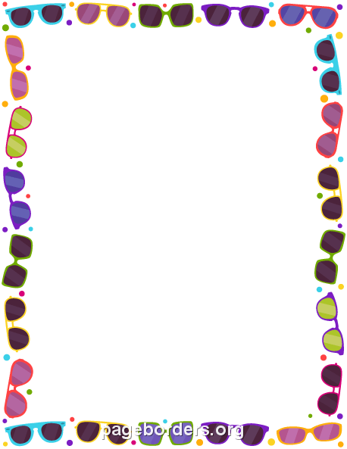

Flips For Fun

Summer Camps

June 19th-22nd

July 17th-20th

July 31st-August 3rd

Camps include indoor and outdoor activities including gymnastics, swimming, sports, games, crafts, and more!!!

Ages 5-12

$200 per week

9am-2pm

Email

flips@flipsforfun.com

to register